## horizontal line



MINI CAFE DATABASE MANAGEMENT SYSTEM

**─**

AKANKSHA ATHELLI

21BTB0A16

**ER DIAGRAM:**

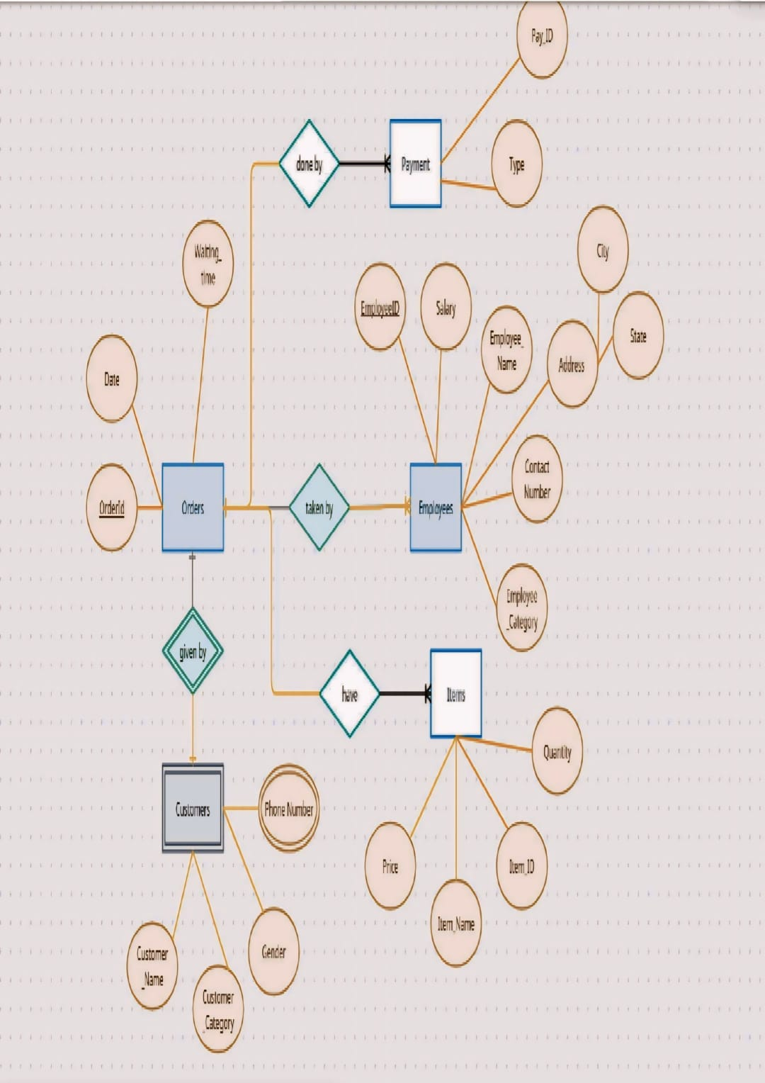

# 

DEFINING TABLES

## ORDERS

**create table Orders(**

**OrderID int,**

**Date Date,**

**Waiting_time Time,**

**PRIMARY KEY(OrderID));**

## CUSTOMERS

**create table Customers(**

**OrderID int,**

**Customer_Name varchar(30),**

**Customer_Category varchar(30),**

**Gender varchar(5),**

**PRIMARY KEY(Customer_Name,Customer_Category,Gender),**

**FOREIGN KEY(OrderID) REFERENCES Orders(OrderID));**

## CUSTOMER_PHONE

**create table Customer_Phone(**

**Phone_NO1 varchar(11),**

**Phone_NO2 varchar(11),**

**OrderID int,**

**PRIMARY KEY(OrderID),**

**FOREIGN KEY(OrderID) REFERENCES Orders(OrderID));**

## ITEMS

**Create table Items(**

**Item_ID int,**

**OrderID int,**

**Item_Name varchar(50),**

**Price int,**

**Quantity int,**

**FOREIGN KEY(OrderID) REFERENCES Orders(OrderID));**

## EMPLOYEES

**create table Employees(**

**Employee_ID int,**

**Salary int,**

**Employee_Name varchar(30),**

**City varchar(30),**

**State varchar(30),**

**Contact_Number varchar(11),**

**Employee_Category varchar(20),**

**PRIMARY KEY(Employee_ID));**

## PAYMENTS

**create table Payment(**

**Pay_ID int,**

**Type varchar(20),**

**OrderID int ,**

**PRIMARY KEY(Pay_ID),**

**FOREIGN KEY(OrderID) REFERENCES Orders(OrderID));**

INSERTING VALUES

## ORDERS

**insert into Orders values(1020,'2024-02-10',15);**

**insert into Orders values(1021,'2024-02-10',12);**

**insert into Orders values(1022,'2024-02-10',20);**

**insert into Orders values(1023,'2024-02-11',20);**

**insert into Orders values(1024,'2024-02-11',15);**

**insert into Orders values(1025,'2024-02-11',12);**

**insert into Orders values(1026,'2024-02-12',12);**

**insert into Orders values(1027,'2024-02-12',12);**

**insert into Orders values(1028,'2024-02-12',20);**

**insert into Orders values(1029,'2024-02-13',20);**

**insert into Orders values(1030,'2024-02-13',20);**

**insert into Orders values(1031,'2024-02-13',20);**

**insert into Orders values(1032,'2024-02-13',15);**

**insert into Orders values(1033,'2024-02-14',15);**

**insert into Orders values(1034,'2024-02-14',12);**

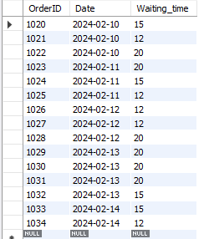

## CUSTOMERS

**insert into Customers values(1020,'Ramu','Student','M');**

**insert into Customers values(1021,'Ravi','Teaching','M');**

**insert into Customers values(1022,'Sailu','Student','F');**

**insert into Customers values(1023,'Akhi','Non-Teaching','F');**

**insert into Customers values(1024,'Akhira','Others','F');**

**insert into Customers values(1025,'Kanika','Student','F');**

**insert into Customers values(1026,'Balu','Teaching','M');**

**insert into Customers values(1027,'Manikyam','Teaching','F');**

**insert into Customers values(1028,'Srinivas','Non-Teaching','M');**

**insert into Customers values(1029,'Uma','Student','M');**

**insert into Customers values(1030,'Tanmayee','Student','F');**

**insert into Customers values(1031,'Ashray','Others','M');**

**insert into Customers values(1032,'Shivani','Non-Teaching','F');**

**insert into Customers values(1033,'Sonu','Student','M');**

**insert into Customers values(1034,'Diya','Non-Teaching','F');**

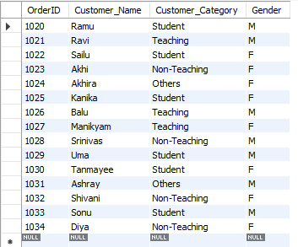

## CUSTOMER_PHONE

**insert into Customer_Phone values('9538046130','9471418987',1020);**

**insert into Customer_Phone values('8772752889','7980259834',1021);**

**insert into Customer_Phone values('9772199632','9643400360',1022);**

**insert into Customer_Phone values('8391736156','8333895124',1023);**

**insert into Customer_Phone values('9049310220','8648544036',1024);**

**insert into Customer_Phone values('8861589382','9655138667',1025);**

**insert into Customer_Phone values('9651341011','9189762885',1026);**

**insert into Customer_Phone values('7375231738','8478986748',1027);**

**insert into Customer_Phone values('8073482966','8557089728',1028);**

**insert into Customer_Phone values('7932588960','8876658921',1029);**

**insert into Customer_Phone values('8406372864','7530332064',1030);**

**insert into Customer_Phone values('7975397752','7656570577',1031);**

**insert into Customer_Phone values('7695859504','9724480186',1032);**

**insert into Customer_Phone values('8764825395','7399638095',1033);**

**insert into Customer_Phone values('7301964726','8982577634',1034);**

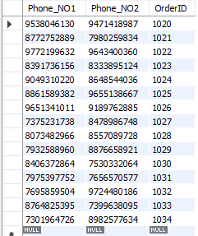

## ITEMS

**insert into items values(01,1020,'Maggie',35,1);**

**insert into items values(03,1020,'Pasta',65,1);**

**insert into items values(04,1021,'Tea',10,2);**

**insert into items values(02,1021,'Sandwich',50,1);**

**insert into items values(06,1022,'Hot Chocolate',20,1);**

**insert into items values(03,1022,'Pasta',65,1);**

**insert into items values(05,1023,'Coffee',12,1);**

**insert into items values(07,1024,'Nuggets',45,1);**

**insert into items values(08,1025,'Veg Burger',100,1);**

**insert into items values(08,1026,'Veg Burger',100,1 );**

**insert into items values(06,1026,'Hot Chocolate',20,1);**

**insert into items values(01,1027,'Maggie',35,2);**

**insert into items values(04,1028,'Tea',10,1);**

**insert into items values(02,1029,'Sandwich',50,2);**

**insert into items values(07,1030,'Nuggets',45,1);**

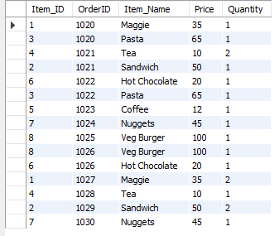

## EMPLOYEES

**insert into employees**

**values(101,30000,'Kiran','Hyderabad','Telangana',8078899615,'Worker');**

**insert into employees values(102,55000,'Vaidehi','Kazipet','Telangana',7187739366,'Chef');**

**insert into employees values(103,30000,'Rahul','Mulugu','Telangana',7113110724,'Worker');**

**insert into employees values(104,35000,'Ramesh','Warangal','Telangana',9543415933,'Senior Worker');**

**insert into employees values(105,30000,'Simi','Medak','Telangana',8995336733,'Worker');**

**insert into employees values(106,55000,'Sanvi','Suryapet','Telangana',9666762932,'Chef');**

**insert into employees values(107,70000,'Ramya','Kazipet','Telangana',7336752207,'Manager');**

**insert into employees values(108,40000,'Paul','Vikarabad','Telangana',9418756457,'Worker');**

**insert into employees values(109,45000,'Viven','Mulugu','Telangana',7287422754,'Chef');**

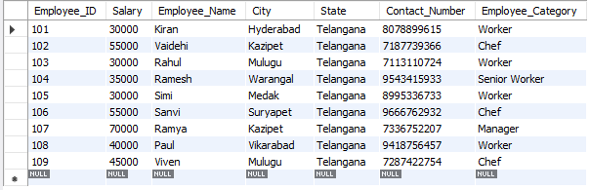

## PAYMENTS

**insert into payment values(112120,'Cash',1020);**

**insert into payment values(112121,'Cash',1021);**

**insert into payment values(112122,'Online',1022);**

**insert into payment values(112123,'Cash',1023);**

**insert into payment values(112124,'Online',1024);**

**insert into payment values(112125,'Online',1025);**

**insert into payment values(112126,'Online',1026);**

**insert into payment values(112127,'Online',1027);**

**insert into payment values(112128,'Online',1028);**

**insert into payment values(112129,'Cash',1029);**

**insert into payment values(112130,'Cash',1030);**

**insert into payment values(112131,'Online',1031);**

**insert into payment values(112132,'Online',1032);**

**insert into payment values(112133,'Online',1033);**

**insert into payment values(112134,'Cash',1034);**

